Name: Roma Shirodkar

Div: D15B

Roll No: 58

Experiment 9

**Aim:** To Understand Continuous monitoring and Installation and configuration of Nagios Core,

Nagios Plugins and NRPE (Nagios Remote Plugin Executor) on Linux Machine.

**Theory:**

**What is Nagios?**

Nagios is an open-source software for continuous monitoring of systems, networks, and

infrastructures. It runs plugins stored on a server that is connected with a host or another server

on your network or the Internet. In case of any failure, Nagios alerts about the issues so that the

technical team can perform the recovery process immediately.

Nagios is used for continuous monitoring of systems, applications, service and business

processes in a DevOps culture.

Why We Need Nagios tool?

Here are the important reasons to use Nagios monitoring tool:

● Detects all types of network or server issues

● Helps you to find the root cause of the problem which allows you to get the permanent

solution to the problem

● Active monitoring of your entire infrastructure and business processes

● Allows you to monitor and troubleshoot server performance issues

● Helps you to plan for infrastructure upgrades before outdated systems create failures

● You can maintain the security and availability of the service

● Automatically fix problems in a panic situation

Features of Nagios

Following are the important features of Nagios monitoring tool:

● Relatively scalable, Manageable, and Secure

● Good log and database system

● Informative and attractive web interfaces

● Automatically send alerts if condition changes

● If the services are running fine, then there is no need to do check that host is an alive

● Helps you to detect network errors or server crashes

● You can troubleshoot the performance issues of the server.

● The issues, if any, can be fixed automatically as they are identified during the monitoring

process

Expt No. 09 Advanced DevOps Lab Roll No. 24

● You can monitor the entire business process and IT infrastructure with a single pass

● The product’s architecture is easy to write new plugins in the language of your choice

● Nagios allows you to read its configuration from an entire directory which helps you to

decide how to define individual files

● Utilizes topology to determine dependencies

● Monitor network services like HTTP, SMTP, HTTP, SNMP, FTP, SSH, POP, etc.

● Helps you to define network host hierarchy using parent hosts

● Ability to define event handlers that runs during service or host events for proactive

problem resolution

● Support for implementing redundant monitoring hosts

Nagios Architecture

Nagios is a client-server architecture. Usually, on a network, a Nagios server is running on a

host, and plugins are running on all the remote hosts which should be monitored.

1. The scheduler is a component of the server part of Nagios. It sends a signal to execute the

plugins at the remote host.

2. The plugin gets the status from the remote host

3. The plugin sends the data to the process scheduler

4. The process scheduler updates the GUI and notifications are sent to admins.

Step 1:

Log in onto your aws account and create a Linux EC2 instance with following inbound rules and name it nagios-host.

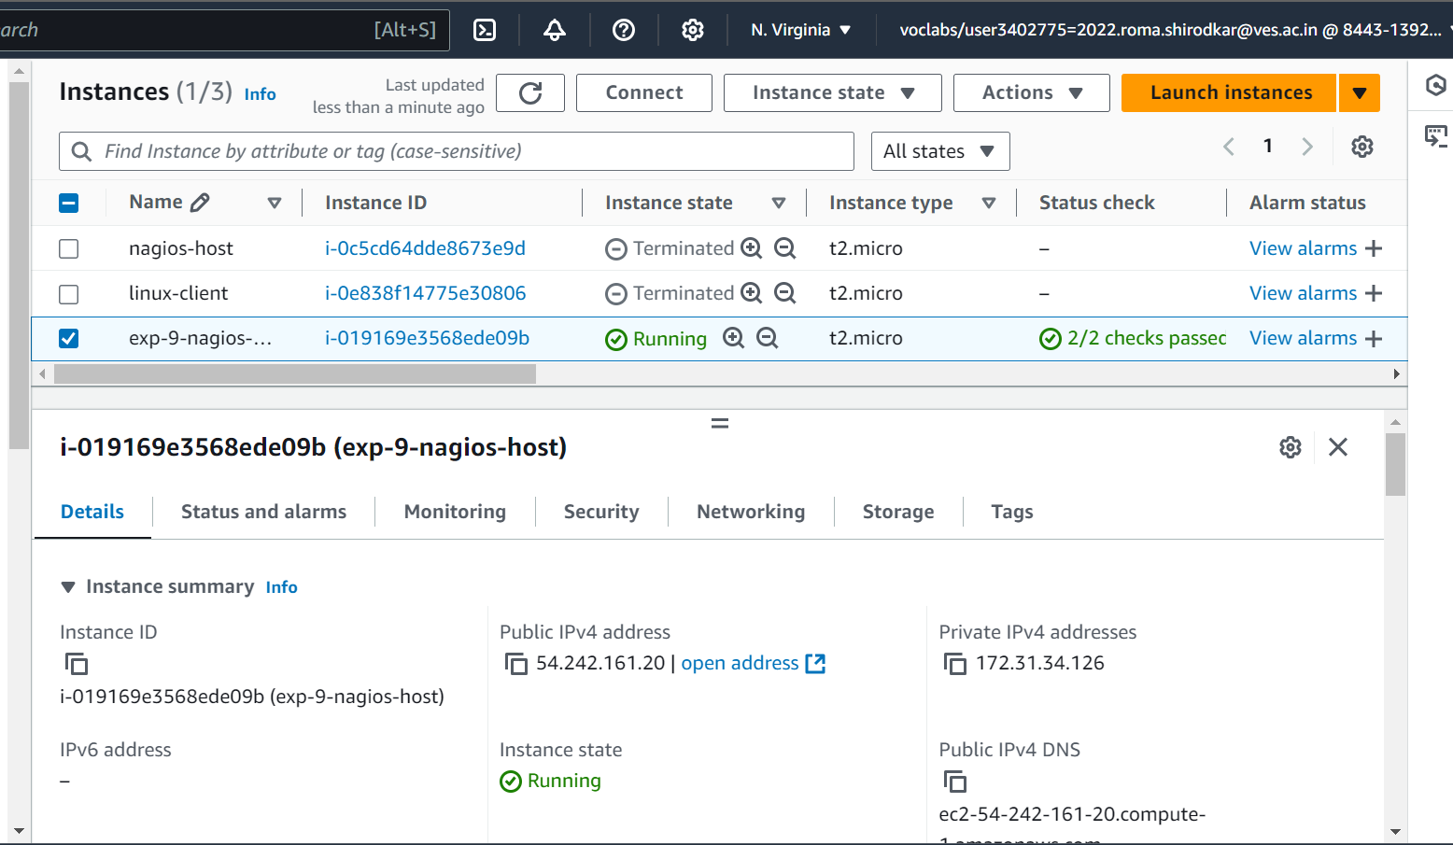

Inbound rules:

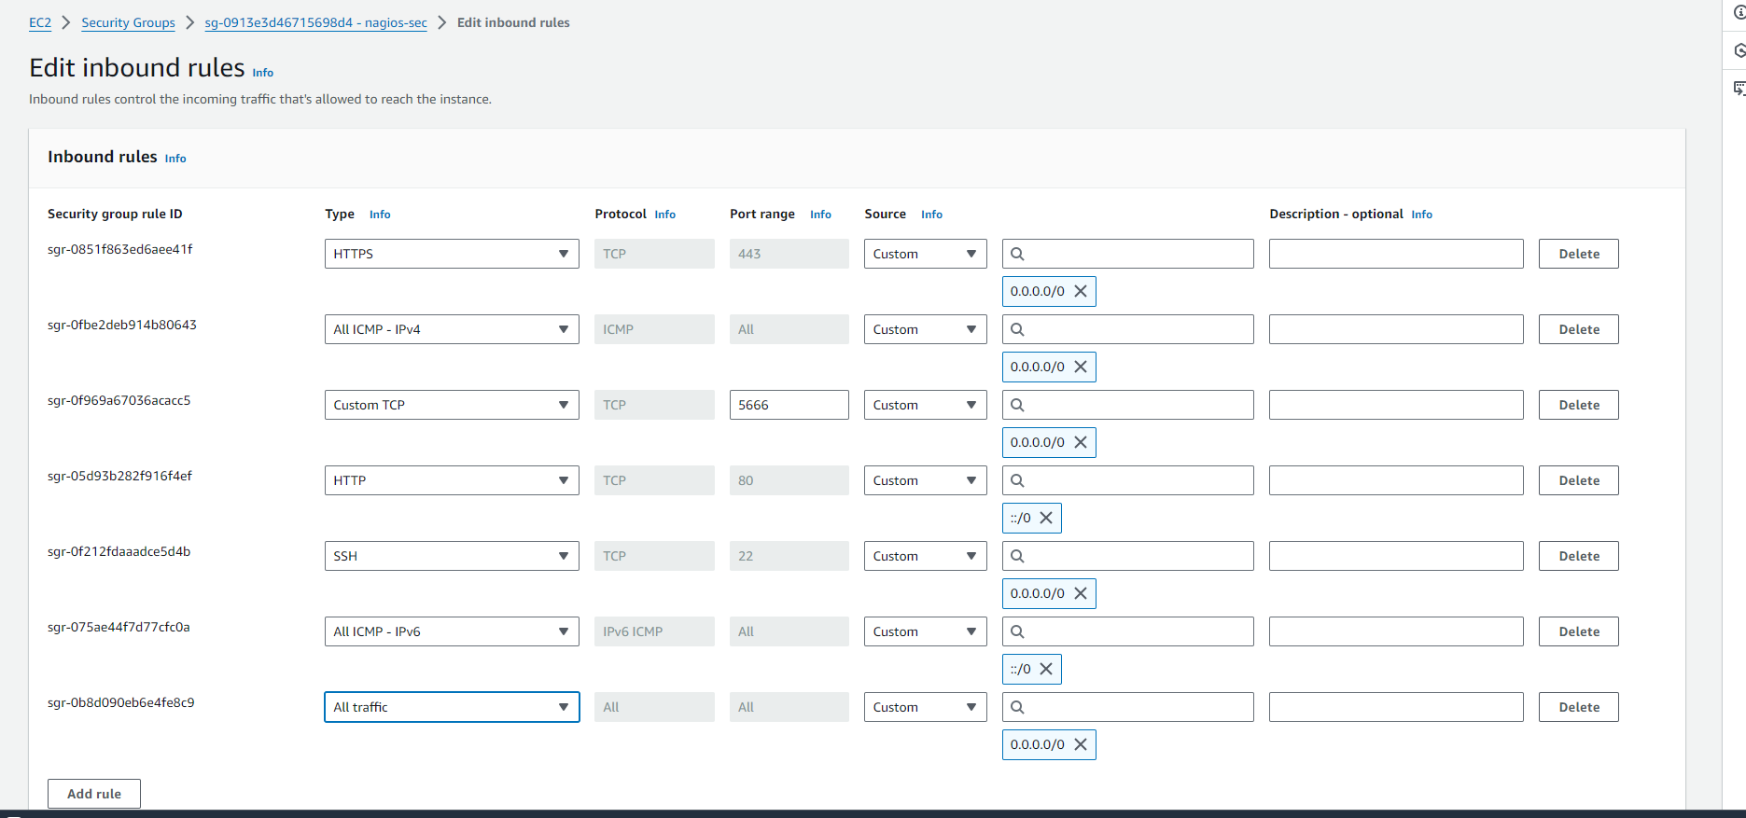

Step 2: SSH into your EC2 instance.

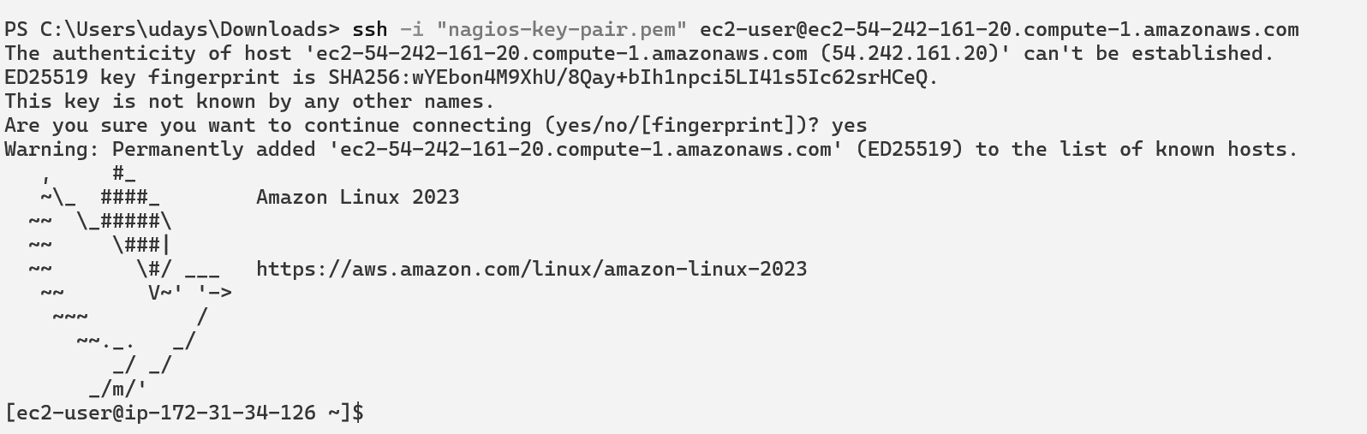

Step 3: Run following commands

sudo su

yum install httpd php -y

yum install gcc glibc glibc-common -y

yum install gd gd-devel -y

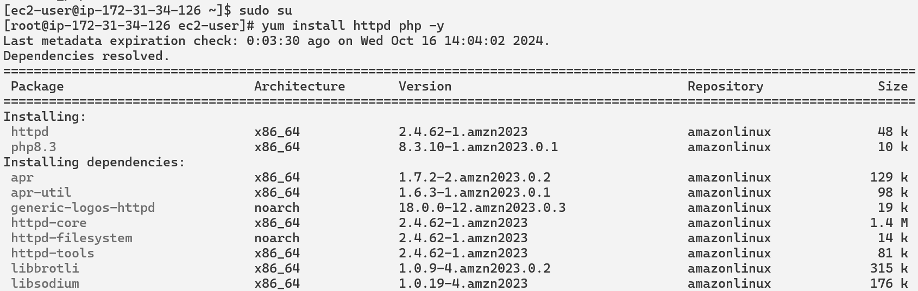

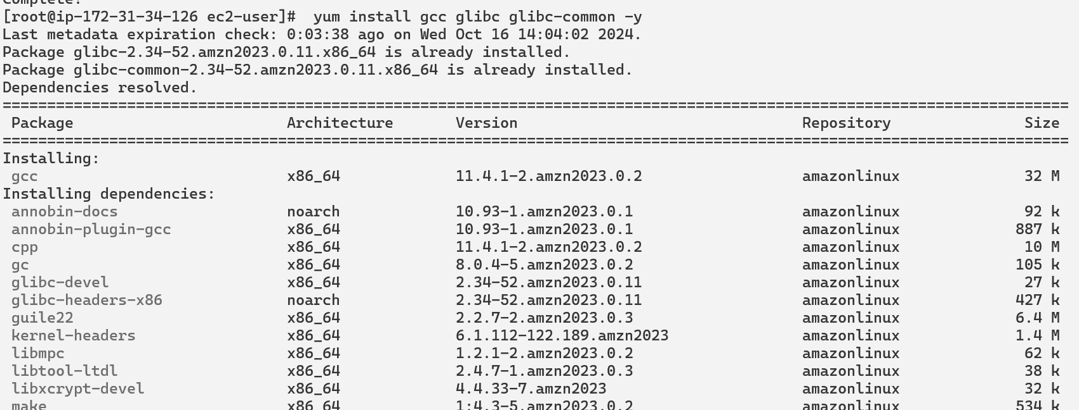

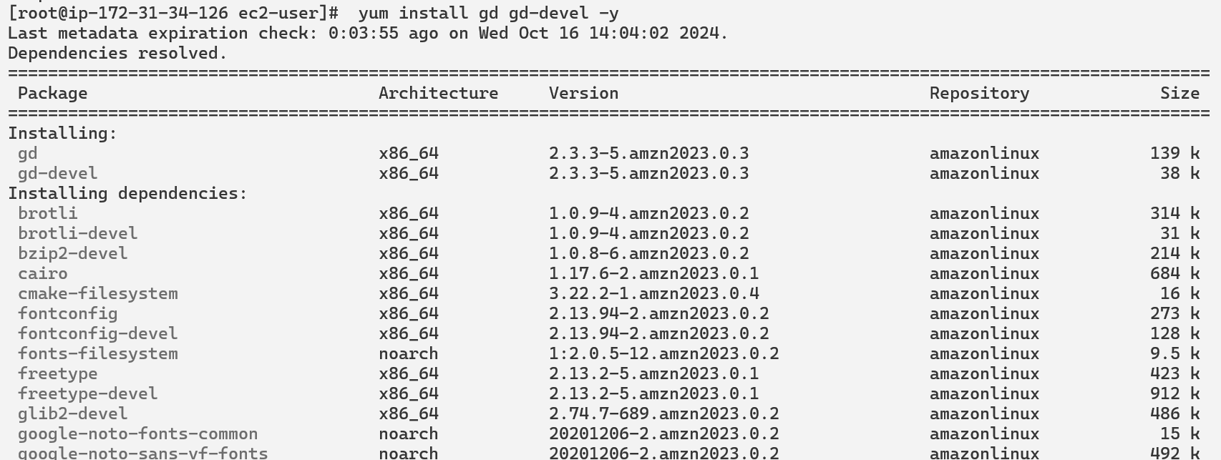

Step 4: Create user to run nagios

adduser -m nagios

Passwd nagios

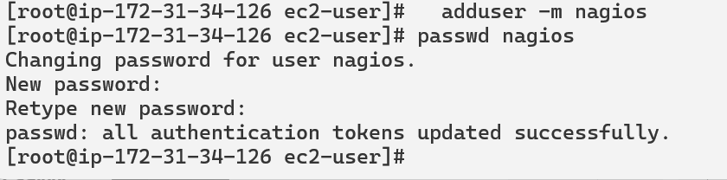

Step 5: Create group and add users into group

groupadd nagioscmd

usermod -a -G nagioscmd nagios

usermod -a -G nagioscmd apache

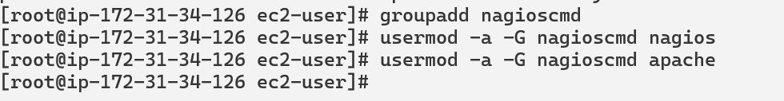

Step 6: Download Nagios core and plugins on created directory

mkdir ~/downloads

cd ~/downloads

wget [http://prdownloads.sourceforge.net/sourceforge/nagios/nagios-4.4.6.tar.gz](https://www.blogger.com/blog/post/edit/4950464559348771172/5588311177318784053)

wget [http://nagios-plugins.org/download/nagios-plugins-2.0.3.tar.gz](https://www.blogger.com/blog/post/edit/4950464559348771172/5588311177318784053)

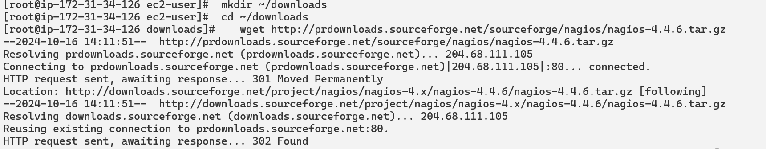

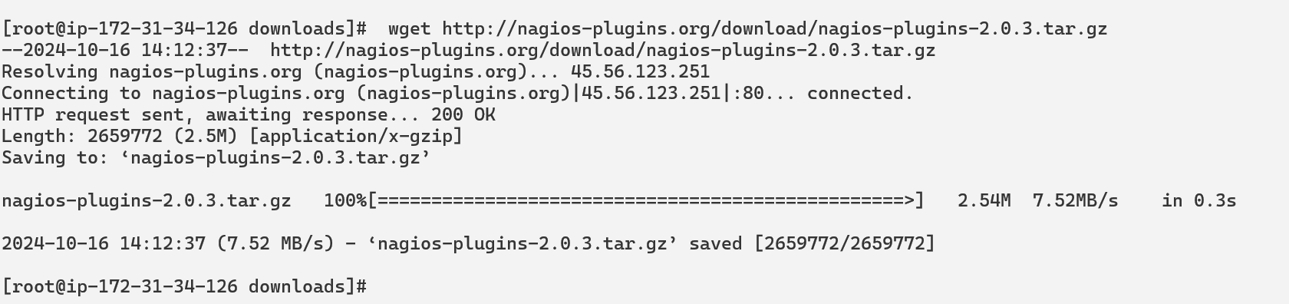

Step 7: compile and installation

tar zxvf nagios-4.4.6.tar.gz

cd nagios-4.4.6

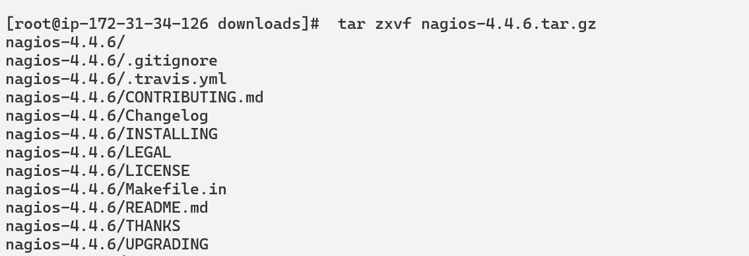

Run configuration script in group

./configure --with-command-group=nagioscmd

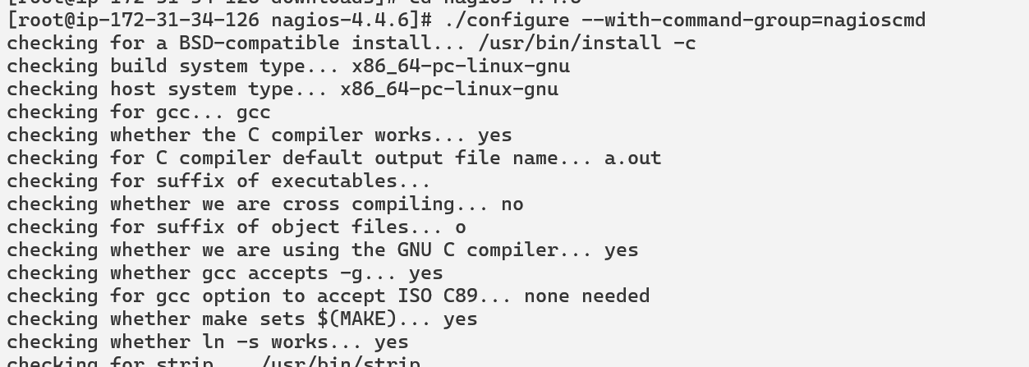

Compile source code

make all

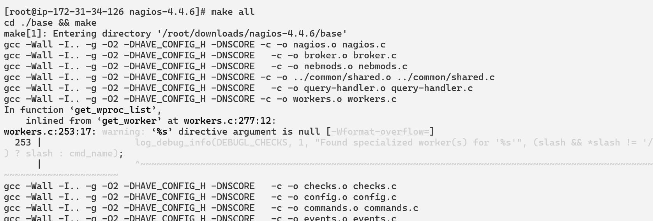

make install

make init

make install-commandmode

make install-config

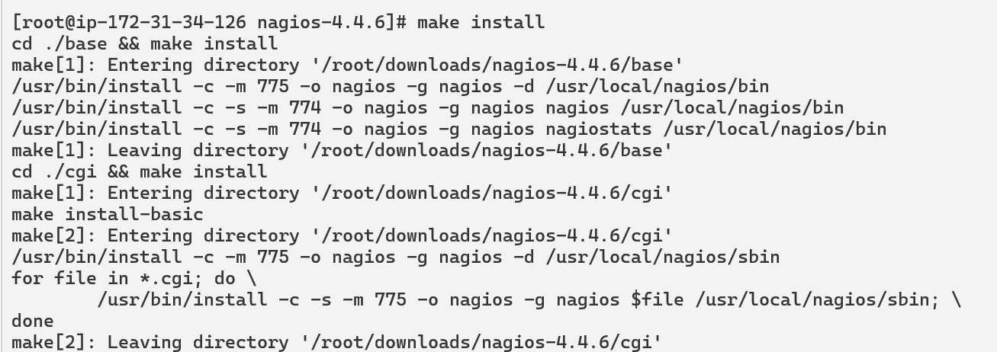



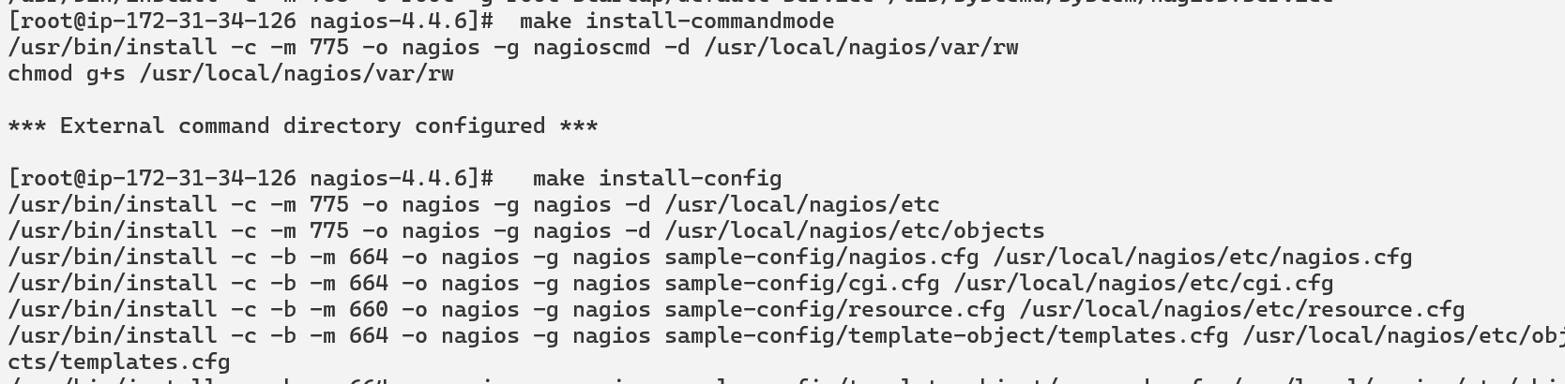

Step 7: Configure web-interface

make install-webconf

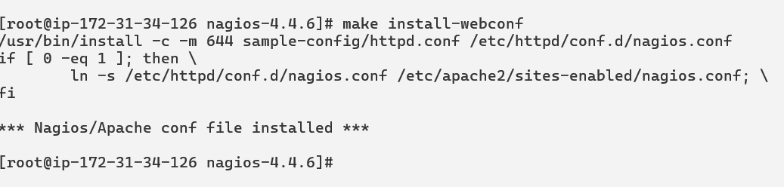

Step 8: Create account for login

htpasswd -c /usr/local/nagios/etc/htpasswd.users nagiosadmin

Give password and restart service

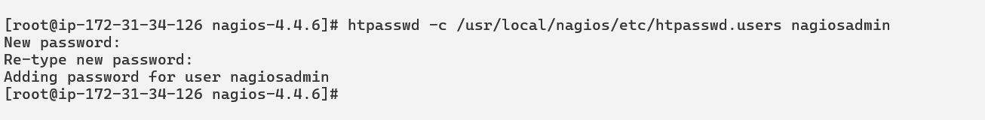

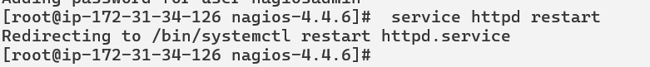

Step 9: Compile and install plugins

cd ~/downloads

tar zxvf nagios-plugins-2.0.3.tar.gz

cd nagios-plugins-2.0.3

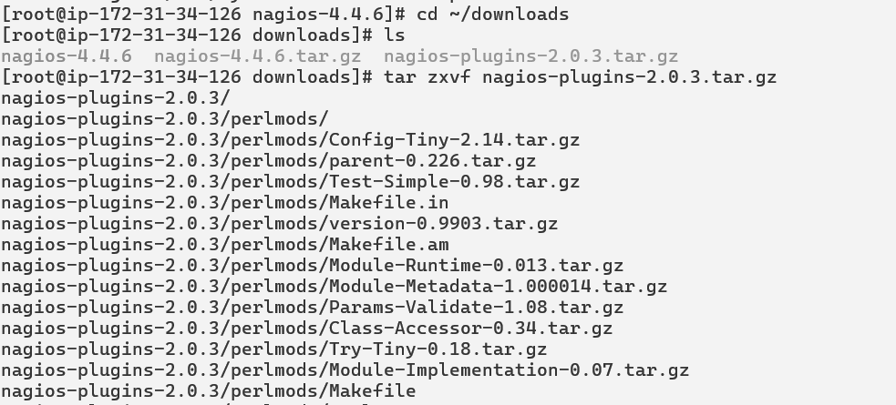

Step 10: Compile and install plugins

./configure --with-nagios-user=nagios --with-nagios-group=nagios

make

make install

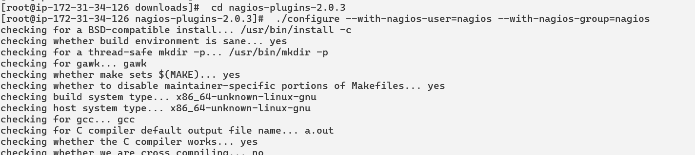

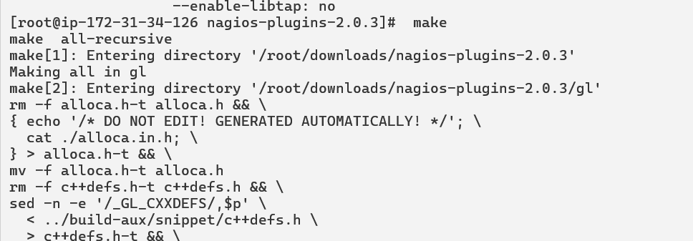

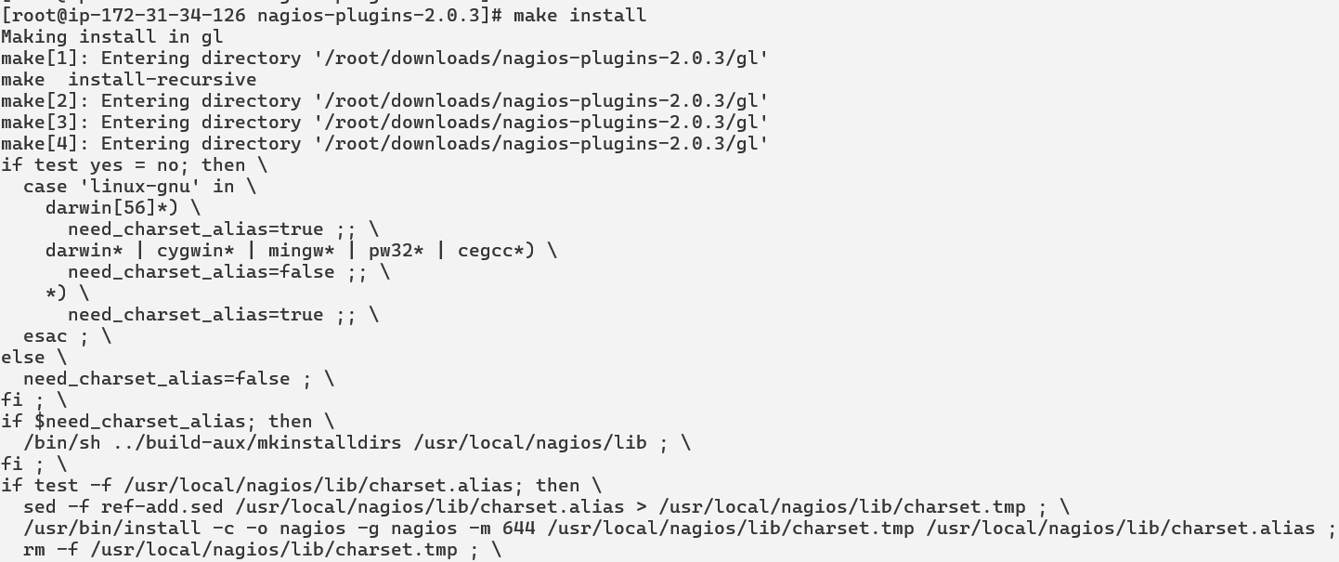

Step 11: nagios start

chkconfig nagios on



Step 12:Verify sample Nagios configuration files

/usr/local/nagios/bin/nagios -v /usr/local/nagios/etc/nagios.cfg

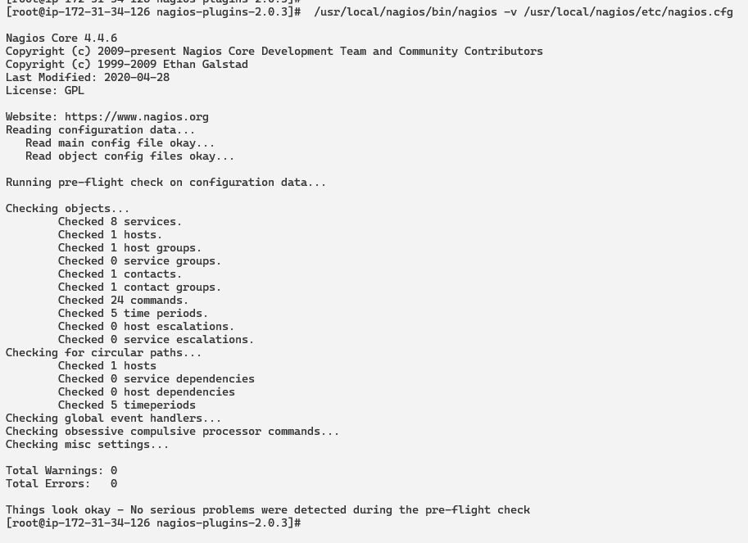

Step 13: If no error then start

service nagios start

service httpd restart

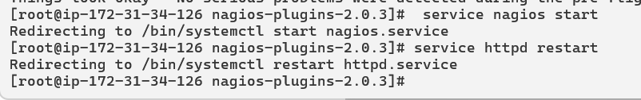

Step 14: For nagios dashboard

Mentioned on browser [http://<ec2_instance_public_ip>/nagios](http://server_ip/nagios)

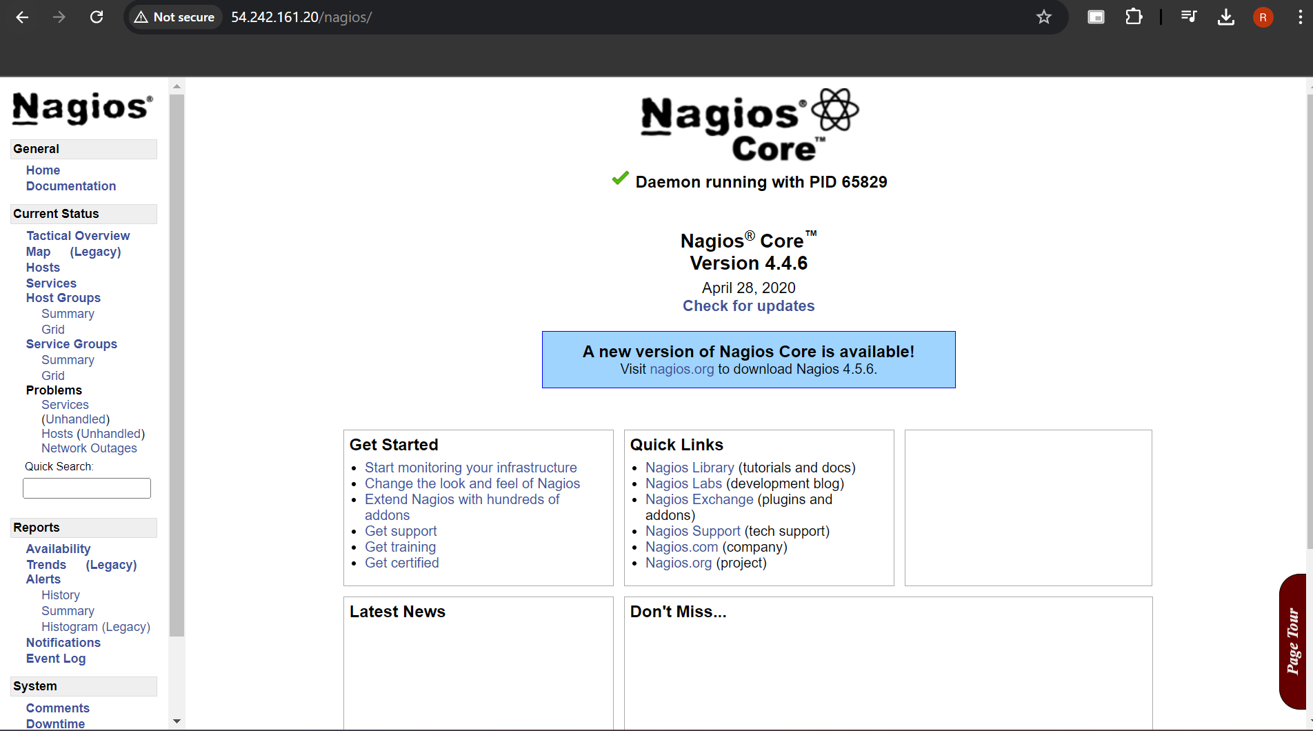

Conclusion: Thus, we learned about Nagios and successfully set it up as a host on our Amazon Linux machine.